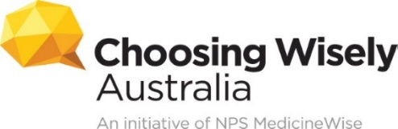
PROMOTION OF AWARD RECIPIENT – CASE STUDY FORM
Please ask the award recipient to fill in the following case study form with as much information as possible. The details will be used as the basis of any communications about their work to implement Choosing Wisely.
By submitting this form, the award recipient consents to their information, quotes and images being used for promotional purposes within their organisation, and by Choosing Wisely Australia on its website, in newsletters and in news media and social media activities. They can opt out of any particular communications channel by emailing choosingwisely@nps.org.au.
IMAGES: Please include two high-resolution (300dpi) photographs of the award recipient: a head and shoulders image of them being presented with their certificate and an image with them involved in their Choosing Wisely project.
Personal details:
Name
Title, organisation
Contact details: Phone, email
How long have you worked for your organisation?
Project rationale:
Why did you embark on this project?
Project outline:
Detail how the project was established and how it ran.
Choosing Wisely benefits:
Explain the benefits of your project/approach: for health professionals, and for consumers.

Results:
What were the results, or how is the project tracking? (*Please include any relevant figures.)
Enablers:
What have been the key enablers to the success of your approach?

Challenges:
What have been some of the challenges you encountered?
Future directions:
How do you think this approach could be used more broadly?
Any other quotes?
For any other information you would like to provide that hasn’t been covered earlier.

CONTACT:
Choosing Wisely Lead
Email: choosingwisely@nps.org.au

